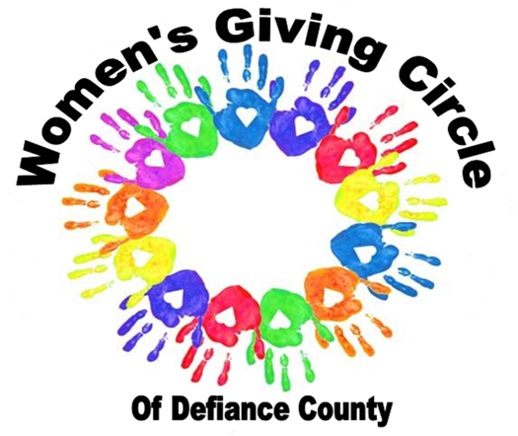
OUR MISSION:

To support programs that impact the lives of women and children through:education, direct projects, and partnering with other organizations.

OUR PURPOSE:

To cultivate women as philanthropic leaders. To educate, inspire, and assist women to become leaders, well informed, self-sufficient, and contributing members of society.

Women’s Giving Circle Scholarship Fund

The Women’s Giving Circle Scholarship Fund was established in 2021 to provide an opportunity for personal growth for a female in Defiance County to further their education. This scholarship will be a minimum of $1,000 and made payable directly to the college or university of their choice. Preference will be given to qualified students who have the greatest financial need. This scholarship may be renewable for eligible applicants.

Eligible Applicants / Qualified Persons:

- Applicant must have graduated from a Defiance County High School or been a resident of Defiance County for two or more years
- Will attend either The Defiance College or Northwest State Community College
- Will be a non-traditional student age 20 or older starting their college experience.
- First preference will be given to “first time college students” or those not currently holding a degree
- Any Major is eligible

Application Information
Applications should be completed and mailed to The Defiance Area Foundation, 613 West Third St., Defiance, OH. 43512. Applications will be accepted with a postmark no later than March 31.

Women’s Giving Circle Scholarship Fund

PART I – APPLICANT INFORMATION – print or type

Name:
last first middle
Permanent Address:
street address

city |  | state |  | zip
Date of Birth: | Sex: | - M | - F

Home Phone: Cell Phone:
College: Anticipated College Graduation Date: ______
College: City, State, Zip: ______

College Acceptance Letter Received (date)_____________ High School Graduation Year:

How did you hear about this scholarship? ______

- Describe how a scholarship will impact your education.

- Describe your involvement and volunteer activities in your community.

- Share any information or factors, which you feel warrant special attention, including family history, unusual personal, family or financial circumstances or challenges. Please include any future or life goals if know (feel free to attach an additional sheet of paper if needed).

I am willing to be available for an interview and understand I may be contacted by a member of the Women’s Giving Circle to review and discuss my application and be in a photo if awarded.

By affixing my signature to this application, I verify that all statements above are true.

Signature Date

